**Name:** Rameen **Roll No:** 2023-EE-03

EE-322L Analog and Digital Communication Marks Obtained: ________

**Lab Report**

**Experiment No. 7**

**FM Modulation using PLL**

**Note:**

* **Don’t forget to include the two rubrics tables (available at the end in this document), otherwise reports will not be graded.**
* **Copy-pasted and plagiarized reports will get zero marks**

1. **Objective**
2. **Technical Background**
3. **Task-1**
   1. ***Description***

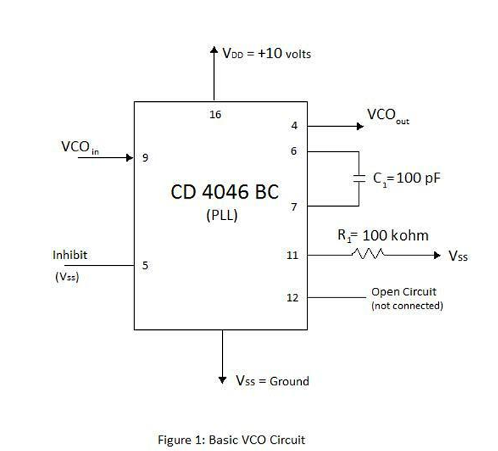

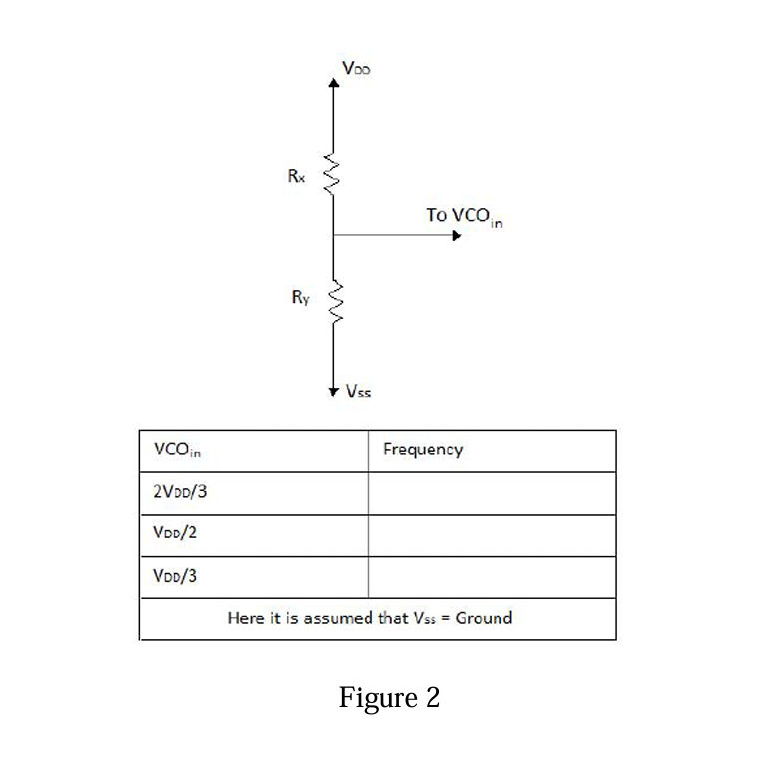

Investigate the above circuit by giving it different inputs through the circuit as shown in Figure 2. Find the frequency of the three VCO input voltages as shown in the table of Figure 2. From that information, determine 𝑘𝑓 for your modulator.

* 1. ***Circuit, Design and Calculations***

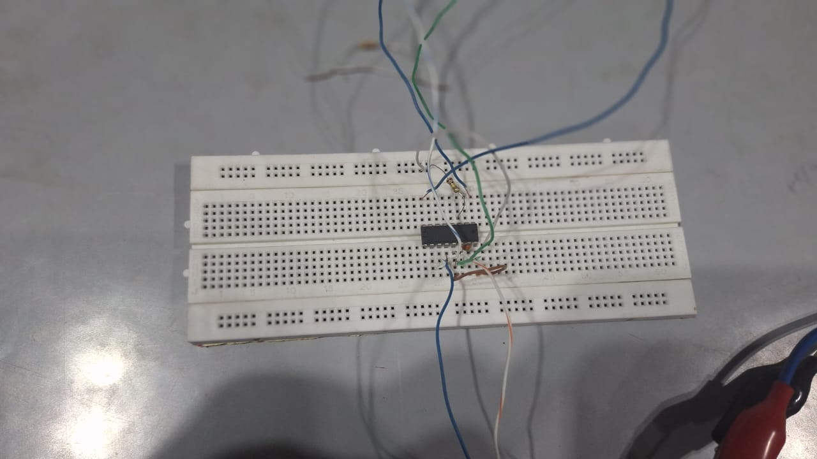

|  |  |
| --- | --- |
| VCOin | Frequency |
| 2VDD/3 | 142.8 kHz |
| VDD/2 | 109.1 kHz |
| VDD/3 | 66.7 kHz |

* 1. ***Results and Discussions (with all graphs and snaps)***

1. **Task-2**
   1. ***Description***
   2. ***Circuit, Design and Calculation***
   3. ***Results and Discussions (with all graphs, and snaps)***
2. **Task-3**
   1. ***Description***
   2. ***Circuit, Design and Calculations***
   3. ***Results and Discussions (with all graphs and snaps)***
3. **Task-4**
   1. ***Description***
   2. ***Circuit, Design and Calculations***

* 1. ***Results and Discussions (with all graphs and snaps***

1. **Task-5**
   1. ***Description***
   2. ***Results and Discussions (with all graphs, and snaps)***
2. **Conclusion**

**Rubrics for Experiment No.**

|  |  |  |  |  |
| --- | --- | --- | --- | --- |
| **Performance** | **Exceeds expectation (2)/(1)** | **Meets expectation (1)/(0.5)** | **Does not meet expectation**  **(0.5)/(0)** | **Marks** |
| **R1: Realization of Experiment’s Hardware on Breadboard.**  **Marks: 0-1** | The circuit is patched correctly, and safely, with neat  connections on the breadboard | The circuit is  patched neatly and correctly, but not in a workable form | Incapable to patch the circuit correctly and  neatly on breadboard |  |
| **R2: Knowledge of theoretical aspects**  **Marks: 0-2** | Has theoretical knowledge required for the experiment | Has partial theoretical knowledge about the experiment | Has no background knowledge about the experiment |  |
| **R3: Conducting Hardware**  **Experiment.**  **Marks: 0-1** | All the required tasks are correctly implemented | The required tasks are partially implemented | Unable to implement all the tasks even with guidance |  |
| **R4: Demonstrate proper results with justification.**  **Marks: 0-2** | Correct results are provided with required justification | Results are provided with  minor errors and/or with little  justification | Results are provided with major errors  and/or with no justification |  |

**Rubrics for Lab Manual No.**

|  |  |  |  |  |
| --- | --- | --- | --- | --- |
| **Performance** | **Exceeds expectation (0.5)/(0.25)** | **Meets expectation (-)/(-)** | **Does not meet expectation (0)/(0)** | **Marks** |
| **R1:** Timely submission  **Marks: 0-**  **0.25** | The submission is on  time | --- | Late submission |  |
| **R2:** Report completenes s  **Marks: 0-0.5** | All relevant calculations, specifications, code, graphs, and results are provided with proper  explanation. | All the relevant calculations,  specifications, code, graphs and results  are provided but with little  explanation and justification. | Most of the relevant graphs, results,  calculations, specifications, and code are missing, as well as their proper  explanation and  justification is also missing. |  |
| **R3:** Error-  free writeup  **Marks: 0-**  **0.25** | The submitted  assignment is without any plagiarism and formatting errors. | Some parts of the submitted  assignment contain formatting errors and plagiarized material. | The submitted assignment is mostly plagiarized and contain formatting errors. |  |